MySQL GROUP BY

**Here**, you will learn how to use **MySQL**GROUP BY to group rows into subgroups based on values of columns or expressions.

## **Introduction to MySQL GROUP BY clause**

The GROUP BY clause groups a set of rows into a set of summary rows by values of columns or expressions. The GROUP BY clause returns one row for each group. In other words, it reduces the number of rows in the result set.

The GROUP BY clause is an optional clause of the SELECT statement. The following illustrates the GROUP BY clause syntax:

SELECT

c1, c2,..., cn, aggregate_function(ci)

FROM

table

WHERE

where_conditions

GROUP BY c1 , c2,...,cn;

In this syntax, you place the GROUP BY clause after the FROM and WHERE clauses. After the GROUP BY keywords, you place is a list of comma-separated columns or expressions to group rows.

MySQL evaluates the GROUP BY clause after the FROM and WHERE clauses and before the HAVING, SELECT, DISTINCT, ORDER BY and LIMIT clauses:

In practice, you often use the GROUP BY clause with aggregate functions such as SUM, AVG, MAX, MIN, and COUNT. The aggregate function that appears in the SELECT clause provides the information of each group.

## **MySQL GROUP BY examples**

Let’s take some examples of using the GROUP BY clause.

### **A) Simple MySQL GROUP BY example**

Let’s take a look at the orders table in the sample database.

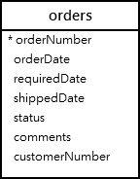

Suppose you want to group values of the order’s status into subgroups, you use the GROUP BY clause with the status column as the following query:

SELECT

status

FROM

orders

GROUP BY status;

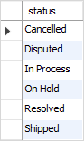

As you can see clearly from the output, the GROUP BY clause returns unique occurrences of status values. It works like the DISTINCT operator as shown in the following query:

SELECT DISTINCT

status

FROM

orders;

### **B) Using MySQL GROUP BY with aggregate functions**

The aggregate functions allow you to perform the calculation of a set of rows and return a single value. The GROUP BY clause is often used with an aggregate function to perform calculations and return a single value for each subgroup.

For example, if you want to know the number of orders in each status, you can use the COUNT function with the GROUP BY clause as follows:

SELECT

status, COUNT(*)

FROM

orders

GROUP BY status;

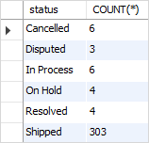

See the following orders and  orderdetails table.

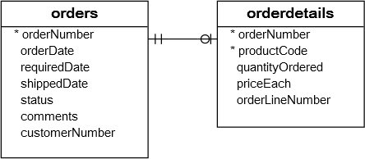

To get the total amount of all orders by status, you join the orders table with the orderdetails table and use the SUM function to calculate the total amount. See the following query:

SELECT

status,

SUM(quantityOrdered * priceEach) AS amount

FROM

orders

INNER JOIN orderdetails

USING (orderNumber)

GROUP BY

status;

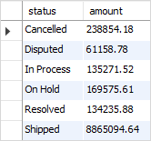

Similarly, the following query returns the order numbers and the total amount of each order.

SELECT

orderNumber,

SUM(quantityOrdered * priceEach) AS total

FROM

orderdetails

GROUP BY

orderNumber;

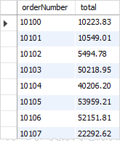

### **C) MySQL GROUP BY with expression example**

In addition to columns, you can group rows by expressions. The following query gets the total sales for each year.

SELECT

YEAR(orderDate) AS year,

SUM(quantityOrdered * priceEach) AS total

FROM

orders

INNER JOIN orderdetails

USING (orderNumber)

WHERE

status = 'Shipped'

GROUP BY

YEAR(orderDate);

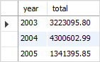

In this example, we used the YEAR function to extract year data from order date ( orderDate). We included only orders with shipped status in the total sales. Note that the expression which appears in the SELECT clause must be the same as the one in the GROUP BY clause.

### **D) Using MySQL GROUP BY with HAVING clause example**

To filter the groups returned by GROUP BY clause, you use a HAVING clause. The following query uses the HAVING clause to select the total sales of the years after 2003.

SELECT

YEAR(orderDate) AS year,

SUM(quantityOrdered * priceEach) AS total

FROM

orders

INNER JOIN orderdetails

USING (orderNumber)

WHERE

status = 'Shipped'

GROUP BY

year

HAVING

year > 2003;

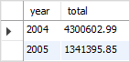

## **The GROUP BY clause: MySQL vs. SQL standard**

The SQL standard does not allow you to use an alias in the GROUP BY clause whereas MySQL supports this.

For example, the following query extracts the year from the order date. It first uses the year as an alias of the expression YEAR(orderDate) and then uses the year alias in the GROUP BY clause.

The following query is not valid in SQL standard:

SELECT

YEAR(orderDate) AS year,

COUNT(orderNumber)

FROM

orders

GROUP BY

year;

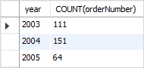

Also, MySQL allows you to sort the groups in ascending or descending orders. The default sorting order is ascending. For example, if you want to get the number of orders by status and sort the status in descending order, you can use the GROUP BY clause with DESC as the following query:

SELECT

status,

COUNT(*)

FROM

orders

GROUP BY

status DESC;

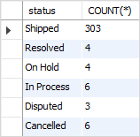

Notice the DESC in the GROUP BY clause sorts the status in descending order. And you can also use the ASC  explicitly in the GROUP BY clause to sort the groups by status in ascending order.

## **The GROUP BY clause vs. DISTINCT clause**

If you use the GROUP BY clause in the SELECT statement without using aggregate functions, the GROUP BY clause behaves like the DISTINCT clause.

The following statement uses the GROUP BY clause to select the unique states of customers from the customers table.

SELECT

state

FROM

customers

GROUP BY state;

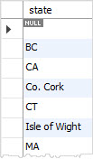

You can achieve a similar result by using the DISTINCT clause:

SELECT DISTINCT

state

FROM

customers;

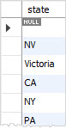

Generally speaking, the DISTINCT clause is a special case of the GROUP BY clause. The difference between DISTINCT clause and GROUP BY clause is that the GROUP BY clause sorts the result set, whereas the DISTINCT clause does not.

Notice that MySQL 8.0 removed the implicit sorting for the GROUP BY clause. Therefore, if you use MySQL 8.0+, you will find that the result set of the above query with the GROUP BY clause is not sorted.

If you add the ORDER BY clause to the statement that uses the  DISTINCT clause, the result set is sorted, and it is the same as the one returned by the statement that uses GROUP BY clause.

SELECT DISTINCT

state

FROM

customers

ORDER BY

state;

## **Summary**

* Use the GROUP BY clause to group rows into subgroups.